Singapore 2025 Race Weekend Report
Understanding Mercedes' Performance Paradox

Executive Summary
George Russell's dominant pole-to-flag victory at the Singapore Grand Prix marked Mercedes' second win of 2025, following their Canada triumph six races prior. This report conducts an analysis of qualifying telemetry, sector performance data, and fuel-corrected race pace, revealing the W16 to posses exceptional mechanical grip through slow-speed traction zones, offset by limitations through sustained high-speed cornering. This performance profile explains why Mercedes has proven competitive only at specific circuit types despite fielding a fundamentally capable package.
An Unexpected Performance Window
Russell described Singapore as being at the bottom of his pre-weekend list of circuits where Mercedes might win in 2025. Mercedes' first victory came at Canada in June, also with Russell converting pole to victory. The connection between Montreal and Marina Bay is not immediately obvious given their contrasting downforce requirements.
Canada features long straights and heavy braking zones, requiring minimal downforce to maximise straight-line speed. Singapore demands maximum downforce across 19 corners connected by short acceleration zones. However, both circuits share a critical characteristic that defines their corner profiles. Neither generates significant sustained lateral load through the tires despite their corner-intensive layouts. Montreal's fast sections connect to heavy braking zones rather than sustained high-speed cornering. Singapore's corners are predominantly slow and require heavy braking before turn-in, with minimal sustained medium-to-high speed sections. Singapore's high ambient temperatures and humidity levels further differentiate it from typical high-downforce venues where sustained aerodynamic loading occurs in cooler conditions.
This distinction matters because sustained lateral load occurs when cars maintain high speeds through long, sweeping corners where aerodynamic platforms must remain stable under continuous compression. Both Canada and Singapore instead demand strong traction out of slow corners where aerodynamic platforms operate in a different working range. The W16's performance window appears defined by this specific demand.

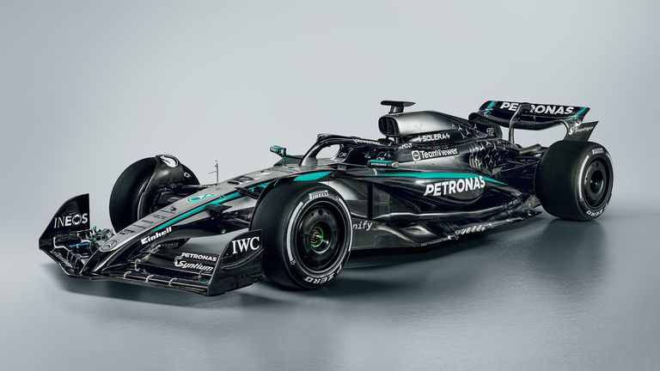
Figure 1- Mercedes W16

Qualifying Analysis: Locating the Mechanical Advantage
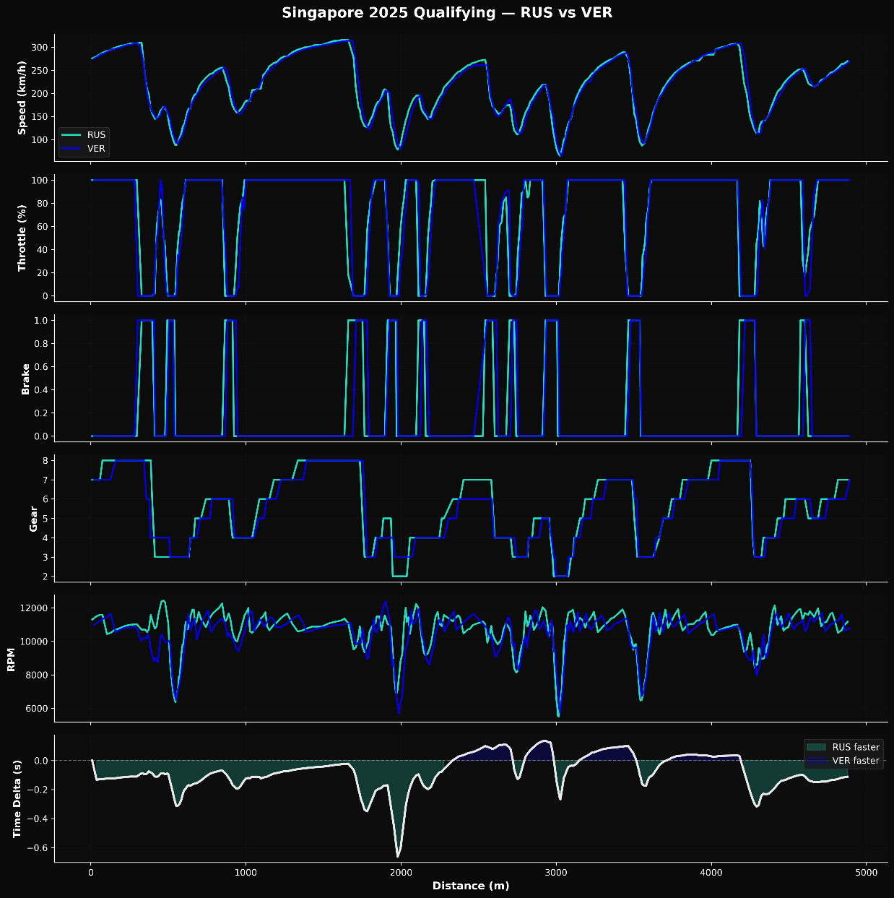
Figure 2 - Qualifying performance (Russell vs Verstappen)
The telemetry comparison between Russell and Verstappen isolates where Mercedes generated their two-tenth qualifying advantage. Figure 2 shows that Russell held a delta of up to 0.6 seconds through the early stages of the middle sector before Verstappen recovered just under five tenths by the lap's conclusion. The speed trace reveals the source of Russell's advantage. Through the sequence of ninety-degree slow corners in sector two, Russell carried marginally higher minimum speeds by getting on the throttle earlier on the exits of T7 through T11. A correction on the T13 exit meant Russell applied full throttle later than Verstappen, leading to a reduction in the time delta built through the previous corners.
Throttle input data in tandem with higher average RPM through the middle sector indicates the W16 was generating better traction out of Singapore's constant slow-speed exits and maintaining a higher power band through these critical acceleration phases. This advantage was complemented by a lower downforce setup that enabled higher speeds on the straights. The gear selection data confirms Russell could hold lower gears longer through the acceleration phases without breaking traction, allowing the power unit to operate in its optimal range while Verstappen needed to shift earlier to manage wheelspin. The W16 was translating available power into forward momentum more effectively through the specific speed range that defines sectors one and two at Marina Bay. However, sector 3 tells a different story.
Sector Performance: Limitations
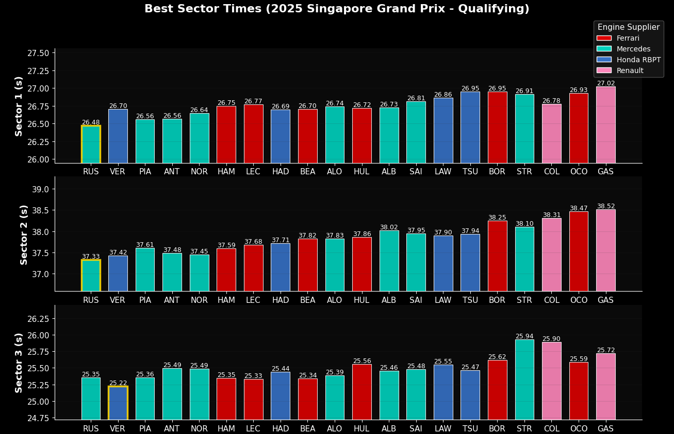
Figure 3- Sector Peformance Qualifying
Verstappen recovered 0.13 seconds through sector three, as shown in Figure 3, without Russell making identifiable errors. Every Mercedes-powered entry lost relative performance in this final sector compared to Ferrari and Honda RBPT competitors. However, race top speed data across the Mercedes Power Unit users showed the highest peak velocities, confirming adequate power unit performance. The telemetry reveals Russell, conversely to sectors 1 and 2, shifting up through gears earlier than Verstappen across the final three corners. This short-shifting technique indicates the W16 struggled to maintain its aerodynamic platform through sustained medium-speed cornering under Singapore's high ambient temperatures.
Sector three's longer radius corners taken at higher sustained speeds demand continuous aerodynamic platform stability and heat dissipation management, contrasting with the slow-speed direction changes of sectors one and two where instantaneous traction dominates. Russell's earlier shifts suggest the aerodynamic platform reached its stable operating limit under these sustained loading conditions combined with thermal stress, explaining the performance convergence despite Mercedes' dominance through the circuit's slow-speed sections.

Race Analysis: Fuel Correction and Sustained Performance
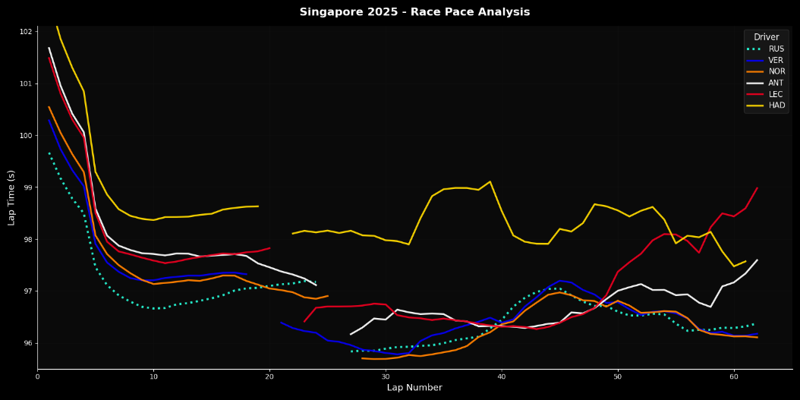
Figure 4 - Raw Race Pace Analysis
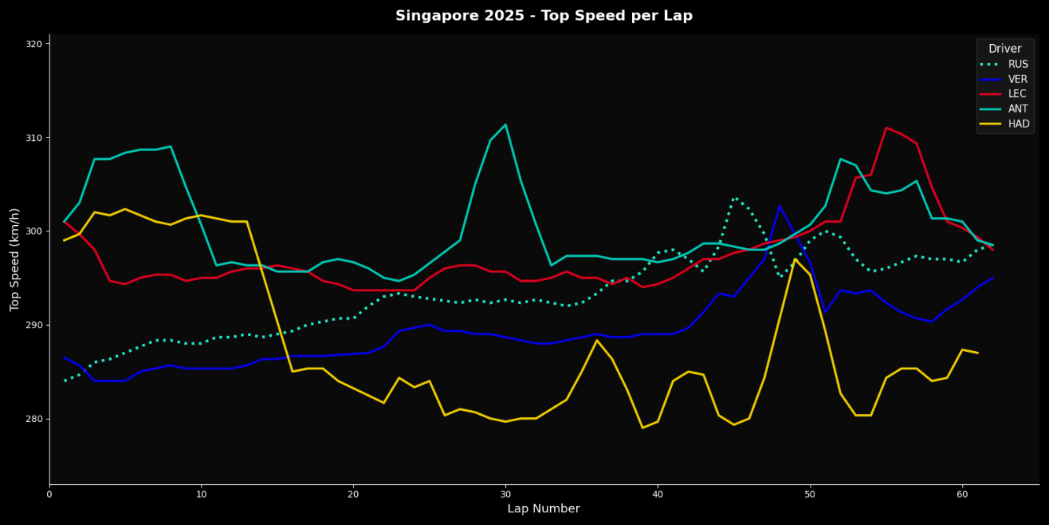
Figure 5 - Top Speed per Lap
Raw race lap times (Figure 4) show apparent pace improvement from the race start to end across all competitors. Top speed data (Figure 5) correlates with this trend, Russell who spent most of the race in free air increased in top speed lap on lap, confirming fuel load as the primary variable affecting lap times. Applying fuel correction based on one hundred ten kilogram starting load, sixty-two lap distance, and point-zero-three seconds per kilogram impact reveals actual performance behaviour across race distance.
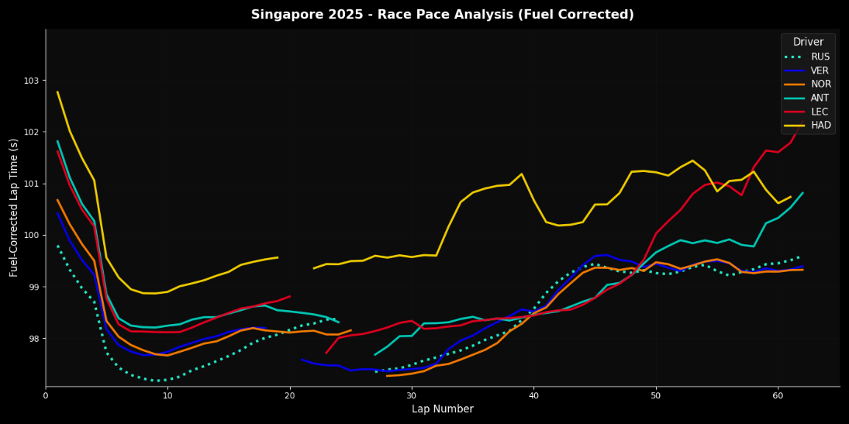
Figure 6 - Race Pace Adjusted for Fuel Load
Figure 6 shows the fuel-corrected race data, revealing whether the aerodynamic limitations identified in qualifying translate to race conditions. Russell's first stint demonstrates the W16 operating at its performance ceiling. His fuel-corrected times from laps five through twenty sit consistently between 0.3 and 0.6 seconds faster than his nearest competitor (Verstappen). The car's traction advantage through slow corners proves sustainable under race fuel loads without accelerating tire degradation.
The second stint reveals controlled pace management rather than performance loss. Russell built a commanding lead before encountering backmarker traffic around lap forty, temporarily allowing Verstappen to reduce the gap and have faster raw pace. Once clear, Russell re-established his advantage, crossing the line with over five seconds in hand. His corrected times remained consistent throughout, confirming the W16's aerodynamic platform limitations identified in sector three qualifying telemetry did not compound across race distance.
Antonelli's race provides insight into the W16 under sustained pressure. His first stint matched Leclerc's corrected pace between 98.0 and 98.5 seconds from laps five through twenty-three. The rookie maintained consistent performance against an experienced driver in comparable machinery. His overtake on Leclerc on lap forty-eight capitalised on superior brake and tire temperature management, while the Ferrari suffered thermal degradation forcing lift-and-coast by the final stint.
The comparison between both Mercedes drivers reveals the W16's operating window. Russell demonstrated the car's ceiling when managed in clean air. Antonelli showed it remains competitive when pushed under pressure. Neither driver experienced progressive performance loss that would indicate fundamental platform instability. Singapore validates that when circuit layout minimises sustained high-speed cornering, the W16 converts qualifying advantage to race victory through genuine sustainable pace.

Conclusions: Decoding the Surprise Box
The W16 generates exceptional traction out of slow corners through superior mechanical grip and effective power delivery at lower speeds. Russell's higher minimum speeds and earlier throttle application through sectors one and two came from chassis characteristics that allow the car to maintain higher power bands through acceleration phases. This strength proves sustainable across race distance when circuits do not demand extended periods of sustained aerodynamic platform stability under high thermal loads.
The limitation appears through sustained medium-to-high speed cornering where the aerodynamic platform must remain stable under continuous compression while managing heat dissipation. The telemetry evidence of Russell short-shifting through sector three confirms this threshold manifests within individual laps rather than only across stint distances. The pattern appearing consistently across Mercedes-powered chassis in the sector three data suggests the aerodynamic platform sensitivity stems from fundamental design philosophy rather than individual team setup choices.
Canada and Singapore both presented conditions where the circuit layout minimises sustained high-speed cornering while maximising slow-speed traction demands. Montreal's circuit flows from slow corners to heavy braking with minimal sustained medium-speed sections. Singapore replicated these conditions despite dramatically different downforce requirements, though its high ambient temperatures revealed the platform's sensitivity under thermal stress in the limited sustained cornering sections. The W16 possesses specific performance characteristics that deliver competitive advantage when track layouts and thermal conditions align with those strengths.

